**EXPERIMENT 2: DETERMINING ACCELERATION DUE TO GRAVITY**

Name: Asmito Ghosh

Registration Number: IACS02721

Group: A2

Laboratory Partner: Ankur Saha

OBJECTIVE:

* To compare the magnitude of gravitational acceleration based on the time of free fall for a body.

THEORY:

* From the equations of motion, we know that if a body falling freely with an acceleration due to gravity (g) for time duration (t), then its height of fall is given by the expression:
$$h=\frac{1}{2}gt^{2} \\ ⇒g=\frac{2h}{t^{2}}$$

* Using photodiodes at given predetermined height difference, the time taken by a body to fall freely from one height to another can be found.

APPARATUS REQUIRED:

* Electromagnet
* Two Photodiodes
* Metre Scale
* Metal Ball

PROCEDURE:

* The experimental setup is created such that an electromagnet was put at the top of a stand, followed by the two photodiodes below it such that the metal ball passes through uninterrupted when made to fall from the magnet.
* Using a metre scale, a specific distance between the two photodiodes are chosen.
* The metal ball is made to hang from the electromagnet and when the magnet is switched off, the ball falls through the photodiodes.
* The time duration of the fall was noted as displayed.
* The steps are repeated to record up to 5 observations for the given distance.
* Keeping the upper photodiode fixed, the lower one’s height is changed. Once again, the previously mentioned steps are performed and the result are recorded.

RESULTS:

|  |  |  |  |  |
| --- | --- | --- | --- | --- |
| Sl. no. | Distance (cm) | Time (s) | Average Time (s) | 2d/t (cm/s) |
| 1 | 30.3 | 0.255 | 0.255 | 237.6 |
| 0.256 |
| 0.255 |
| 0.256 |
| 0.255 |
| 2 | 40.1 | 0.293 | 0.293 | 273.7 |
| 0.293 |
| 0.294 |
| 0.294 |
| 0.293 |
| 3 | 50.0 | 0.326 | 0.326 | 306.7 |
| 0.326 |
| 0.327 |
| 0.326 |
| 0.326 |
| 4 | 60.0 | 0.357 | 0.357 | 336.1 |
| 0.357 |
| 0.356 |
| 0.358 |
| 0.357 |
| 5 | 68.5 | 0.380 | 0.380 | 360.5 |
| 0.380 |
| 0.381 |
| 0.380 |
| 0.380 |

GRAPHS AND CALCULATIONS:

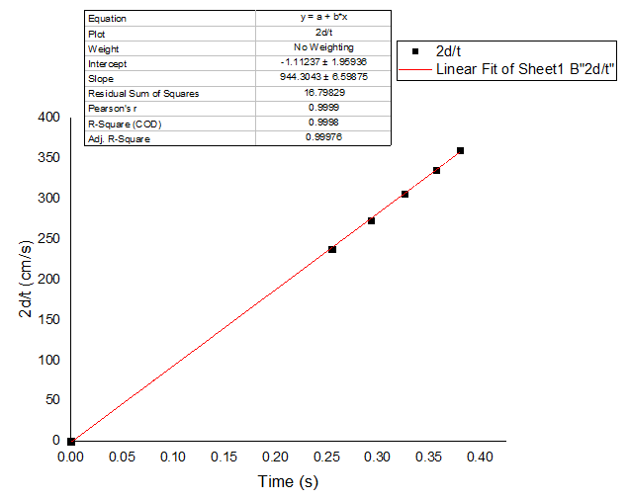

From the graph, we find:

Slope of 2d/t vs Time = 944.3043  
⇒ Acceleration due to gravity (g) = 944.3 cm/s2  
 = 9.443 m/s2

ERROR ANALYSIS:

According to the equations of motions,

⇒

⇒

⇒ max max max

To calculate approximate instrumental error, we are taking one case for each height difference:

1) For h = 30.3, t = 0.255 $⇒$ 
 Maximum Percentage Error = $\left(\frac{0.1}{30.3}+ \frac{0.001}{0.255}\right)*100\%$  
Maximum Percentage Error = 1.11%

2) For h = 40.1, t = 0.293 $⇒$ 
 Maximum Percentage Error = $\left(\frac{0.1}{40.1}+ \frac{0.001}{0.293}\right)*100\%$  
Maximum Percentage Error = 0.93%

3) For h = 50.0, t = 0.326 $⇒$ 
 Maximum Percentage Error = $\left(\frac{0.1}{50.0}+ \frac{0.001}{0.326}\right)*100\%$  
Maximum Percentage Error = 0.81%

4) For h = 60.0, t = 0.357 $⇒$ 
 Maximum Percentage Error = $\left(\frac{0.1}{60.0}+ \frac{0.001}{0.357}\right)*100\%$  
Maximum Percentage Error = 0.73%

5) For h = 68.5, t = 0.380 $⇒$ 
 Maximum Percentage Error = $\left(\frac{0.1}{68.5}+ \frac{0.001}{0.380}\right)*100\%$  
Maximum Percentage Error = 0.67%

Average Percentage Error = 0.85%

$⇒$ Acceleration due to gravity (g) = 9.433 ± .08 m/s2

REMARKS:

Thus, we set up an apparatus to measure the time of free fall from varying heights. By comparing the experimental results with the theoretical calculations based on the equations of motion, we successfully determined the acceleration due to gravity, achieving results within a reasonable margin of error.

ROUGH WORK:

